

**NETWORKING & SYSTEM ADMINISTRATION LAB**

**Experiment No.: 3**

**Aim**

Familiarization of basic linux commands

**Procedure:**

pwd - print working directory it prints current working directory path starting from root.

**syntax:**

$pwd

**output:**

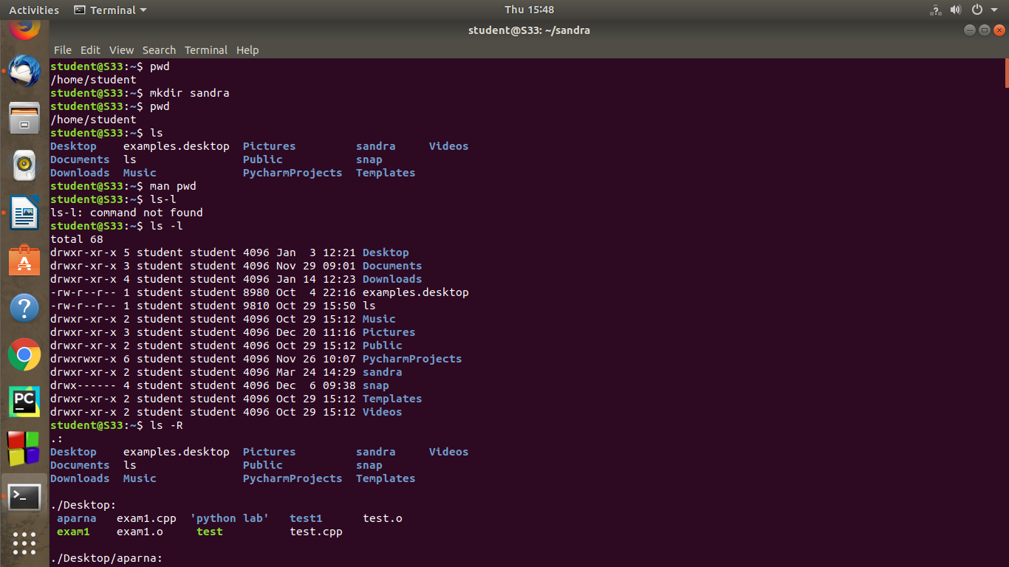

2. **mkdir** - The mkdir command is used to create a new directory under any directory.

**syntax:**

$mkdir directory _name

**output:**



3. ls – ls command is used to display a list of content of a directory.

Syntax:

$ls

**output:**



4. man – man is used to display the manual of any command that we can run on terminal.

Syntax:

$man pwd



5. ls -l - lt will show the list in long list format.

syntax:

$ ls -l

**output:**



6. ls -R - It will display the content of the sub- directories also.

syntax:

$ls -R

**output:**



:

7. ls -a - Show file types (“/” = directory, “*” = executable)

**syntax:**

$ls -a

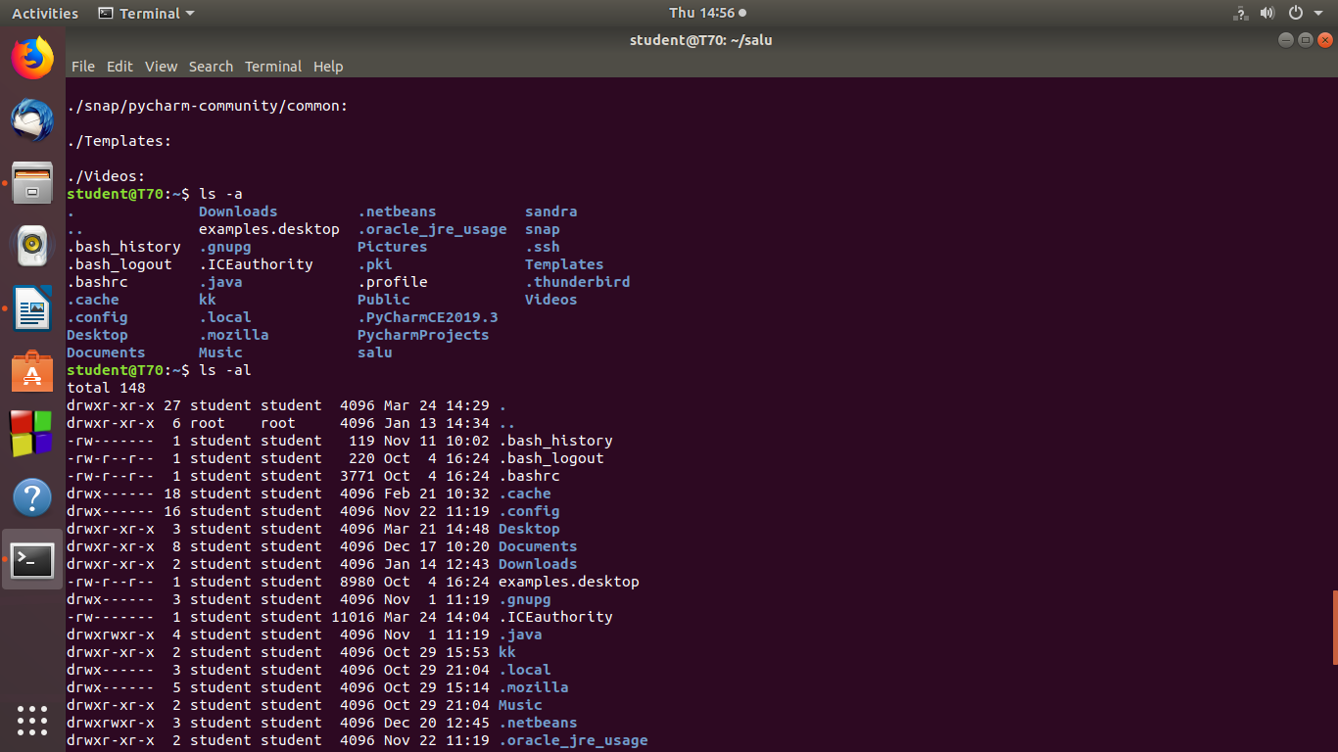

8.ls -al - ordering sequence

**syntax:**

$ls -al



9.cd - command is **used to change the current working directory in Linux and other Unix-like operating systems**.

**syntax:**

$cd

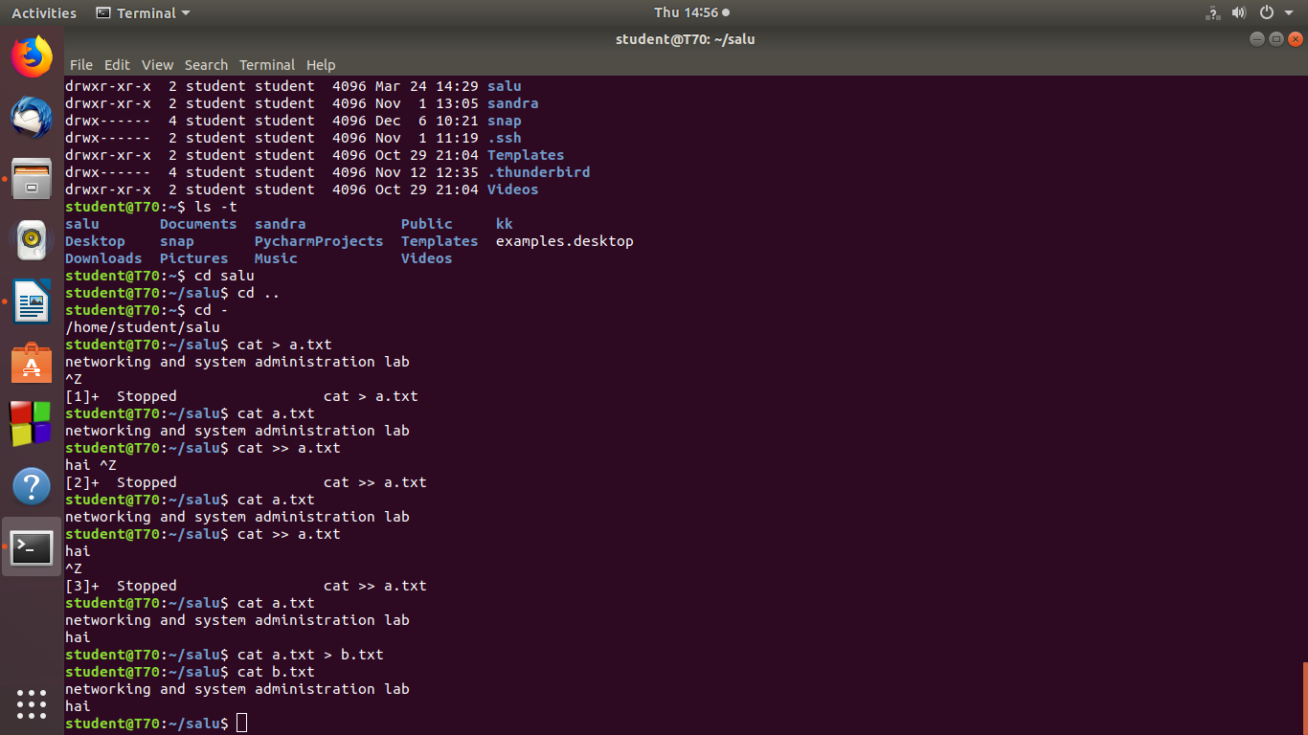

10.cat - print the content of a file onto the standard output stream.

**syntax:**

**$ cat name.txt**

